*Section 1: Multiple-Choice Questions (MCQs)*

1) What does WSL stand for in the context of Windows?

a. Windows Software Locator

b. Windows System Locator

c. Windows Subsystem for Linux

d. Windows Shell Language

Answer: C. Windows Subsystem for Linux

Reason: The Windows Subsystem for Linux (WSL) allows users to run Linux applications on a Windows system seamlessly. It acts as a compatibility layer, enabling native execution of Linux binaries without the need for a virtual machine. This integration facilitates a more convenient environment for developers who require both Linux and Windows functionalities.

2) What is the primary goal of continuous integration (CI) in DevOps?

a. Automating manual testing

b. Frequent integration of code changes

c. Managing cloud infrastructure

d. Monitoring server performance

Answer: B. Frequent integration of code changes

Reason: Continuous Integration (CI) in DevOps aims to facilitate the frequent integration of code changes into a shared repository. This practice automates the process of merging code from individual developers or teams, allowing for early detection and resolution of integration issues. This ensures that the software remains in a consistently functional state, reducing the risk of bugs or conflicts as development progresses.

3) In the Linux command line, what does the cd command do?

a. Copy files and directories

b. Change the working directory

c. Create a new directory

d. Calculate directory size

Answer: b. Change the working directory

Reason: The cd command in the Linux command line is used to change the current working directory.

4) Which of the following is not a Linux distribution?

a. Ubuntu

b. CentOS

c. Docker

d. Debian

Answer: c. Docker

Reason: Docker is not a Linux distribution. Instead, it is a platform designed to help developers build, package, and run applications as containers.

5) What is Docker primarily used for in DevOps and containerization?

a. Managing cloud infrastructure

b. Running virtual machines

c. Packaging and deploying applications in containers

d. Managing network security

Answer: c. Packaging and deploying applications in containers

Reason: Docker is primarily used for packaging applications and their dependencies into standardized units called containers. These containers can then be easily deployed and run consistently across different environments.

6) What is the primary purpose of Azure DevOps?

a. Infrastructure management

b. Software development and delivery

c. Network security

d. Virtualization

Answer: b. Software development and delivery

Reason: Azure DevOps is primarily designed to support software development and delivery processes. It provides a suite of tools and services for tasks like version control, continuous integration, continuous delivery (CI/CD), project management, and collaboration.

7) Which components are part of Azure DevOps?

a. Azure App Service and Azure Functions

b. Azure Monitor and Azure Security Center

c. Azure Boards and Azure Pipelines

d. Azure Virtual Machines and Azure SQL Database

Answer: c. Azure Boards and Azure Pipelines

Reason: Azure DevOps is a comprehensive suite of development tools provided by Microsoft. It encompasses a range of services to facilitate the software development lifecycle. Specifically, Azure Boards is a service for work tracking and project management, while Azure Pipelines is used for continuous integration and continuous delivery (CI/CD) workflows.

8) How does Azure DevOps support version control in software development?

a. It provides automated database backups.

b. It tracks changes in source code and manages versions.

c. It monitors server performance.

d. It optimizes network configurations.

Answer: b. It tracks changes in source code and manages versions.

Reason: Azure DevOps supports version control in software development by providing tools for tracking changes in source code and managing different versions of the codebase. It offers version control systems like Git and Team Foundation Version Control (TFVC).

9) In Linux, what is the primary role of the root user?

a. Managing user accounts

b. Running GUI applications

c. Administrative tasks with superuser privileges

d. Monitoring network traffic

Answer: c. Administrative tasks with superuser privileges

Reason: The primary role of the root user in Linux is to perform administrative tasks with superuser privileges. The root user has full control over the system and can access, modify, and configure any file, directory, or system setting. This level of access is necessary for tasks such as installing software, configuring system-wide settings, managing system services, and performing other critical administrative functions.

10) In Azure DevOps, which component is used to define, build, test, and deploy applications?

a. Azure Boards

b. Azure Repos

c. Azure Pipelines

d. Azure Artifacts

Answer: c. Azure Pipelines

Reason: Azure Pipelines is the component used in Azure DevOps to define, build, test, and deploy applications. It provides a robust and customizable Continuous Integration and Continuous Deployment (CI/CD) platform. With Azure Pipelines, you can create automated workflows to build and test your code, then deploy it to various environments.

*Section 2: Labs*

Lab 1: File and Directory Management

Objective: Practice basic file and directory management commands.

Tasks:

1. Create a directory called “lab1” in your home directory.

2. Inside “lab1” create a text file named “sample.txt” with some content.

3. Make a copy of “sample.txt” and name it “sample_copy.txt”

4. Rename “sample_copy.txt” to “new_sample.txt”

5. List the files in the “lab1” directory to confirm their names.

Solution:

Steps to be followed:

Step 1: Create a directory named "lab1" within your home directory.

Step 2: Navigate into the "lab1" directory.

Step 3: Create a text file named "sample.txt" with some content.

Step4: Make a copy of "sample.txt" and name it "sample_copy.txt".

Step 5: Rename "sample_copy.txt" to "new_sample.txt".

Step 6: List the files in the "lab1" directory to confirm their names.

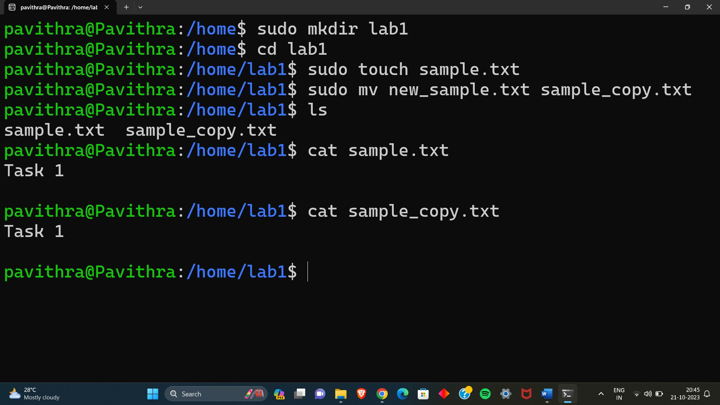

Lab 2: Permissions and Ownership

Objective: Understand and manage file permissions and ownership.

Tasks:

1. Create a new file named “secret.txt” in the “lab2” directory.

2. Set the file permissions to allow read and write access only to the

owner.

3. Change the owner of “secret.txt” to another user.

4. Verify the new permissions and owner using the ls -l and ls -n

commands.

Solution:

Steps to be Followed:

Step 1: Create a new file named "secret.txt" in the "lab2" directory.

Step 2: Set the file permissions to allow read and write access only to the owner.

Step 3: Change the owner of "secret.txt" to another user.

Step 4: Verify the new permissions and owner using the ls -l and ls -n commands.

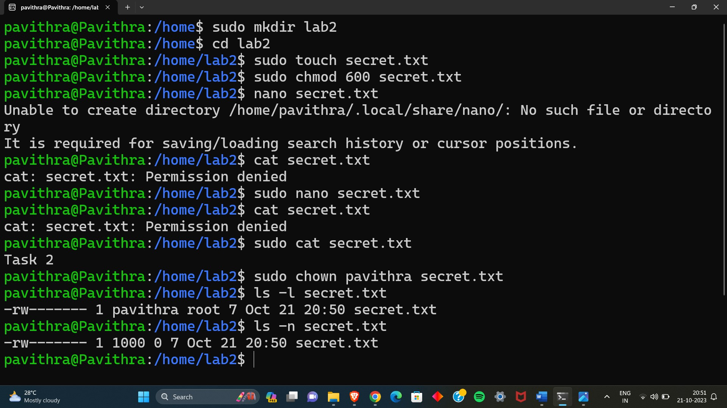

Lab 3: Text Processing with Command Line Tools

Objective: Practice text processing using command-line tools.

Tasks:

1. Create a text file with some random text in the “lab3” directory.

2. Use the grep command to search for a specific word or pattern in the

file.

3. Use the sed command to replace a word or phrase with another in the

file.

4. Use the wc command to count the number of lines, words, and

characters in the file.

Solution:

Steps to be Followed:

Step 1: Create a text file with some random text in the "lab3" directory.

Step 2: Use the grep command to search for a specific word or pattern in the file.

Step 3: Use the sed command to replace a word or phrase with another in the file.

Step 4: Use the wc command to count the number of lines, words, and characters in the file.

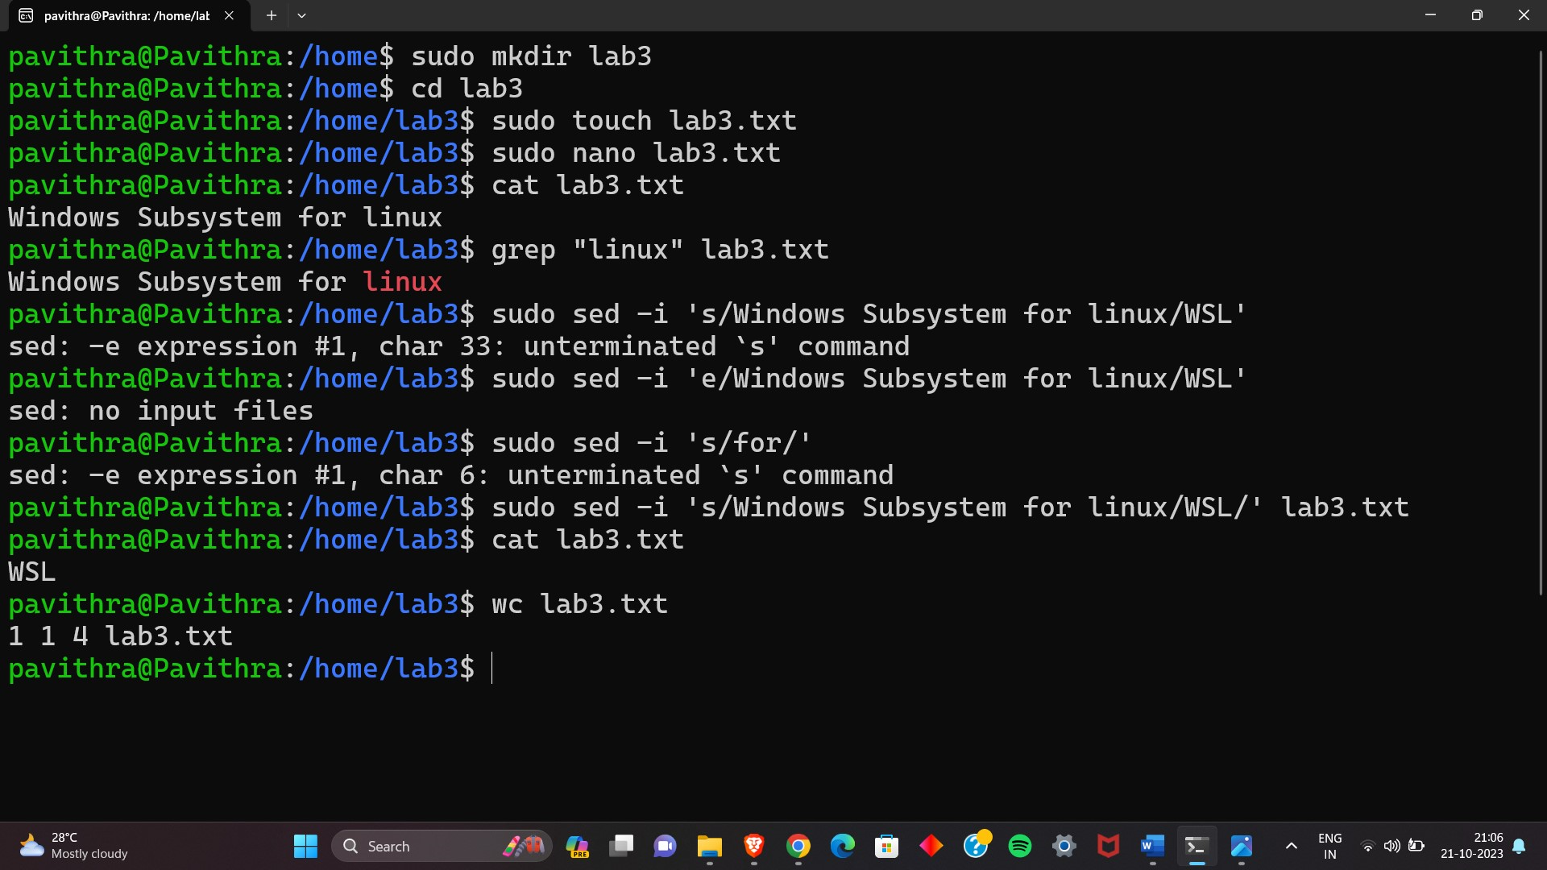

Lab 4: Creating a Simple YAML File

Objective: Create a basic YAML configuration file.

Task:

1. Create a YAML file named “config.yaml”

2. Define key-value pairs in YAML for a fictitious application, including

name, version, and description.

3. Save the file.

4. Validate that the YAML file is correctly formatted.

Solution:

Steps to be Followed:

Step 1: Create a YAML file named "config.yaml".

Step 2: Open the "config.yaml" file in a text editor and add the following content.

Step 3: Save the file in your text editor.

Step 4: Validate that the YAML file is correctly formatted using a YAML validator.

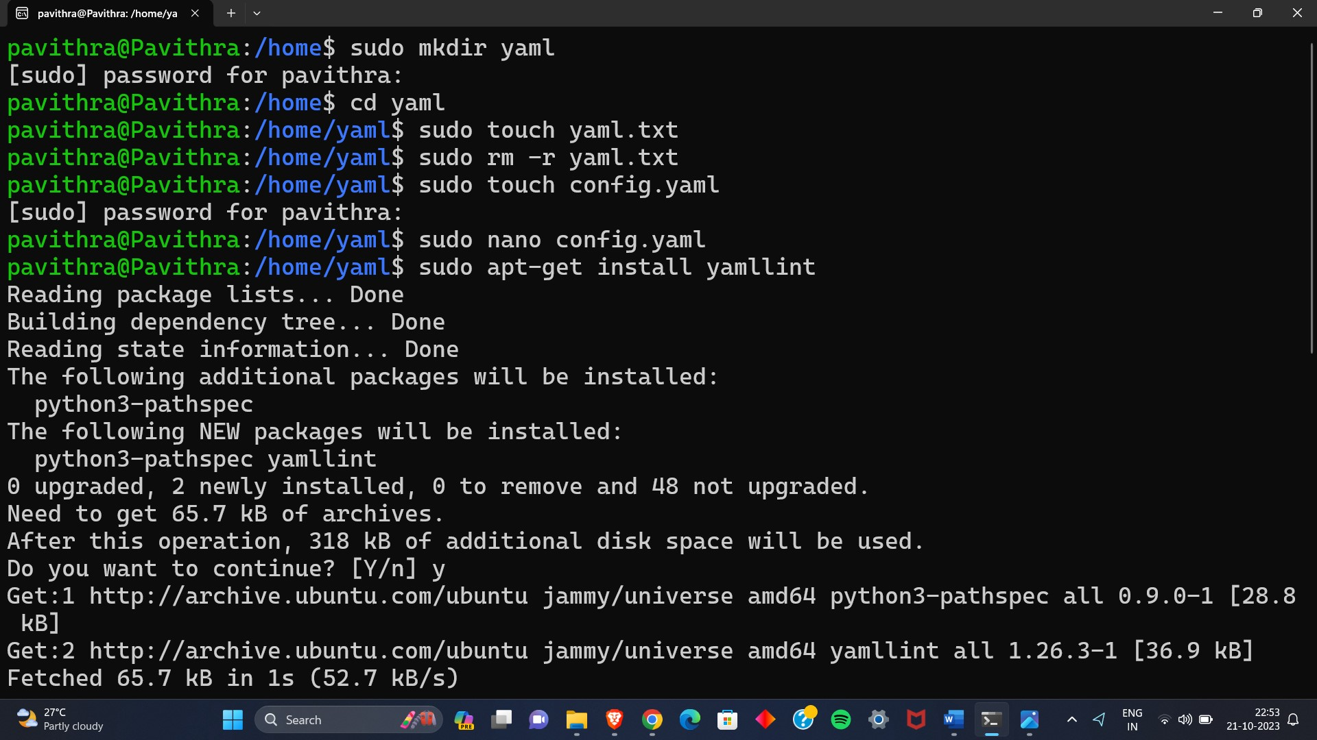

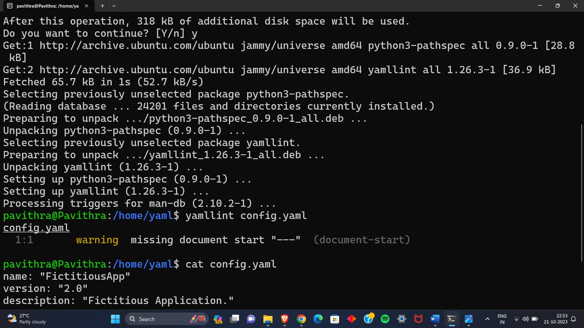

Lab 5: Working with Lists in YAML

Objective: Practice working with lists (arrays) in YAML.

Task:

1. Create a YAML file named “fruits.yaml”

2. Define a list of your favorite fruits using YAML syntax.

3. Add items from the list.

4. Save and validate the YAML file.

Solution :

Steps to be Followed:

Step 1: Create a YAML file named "fruits.yaml"

Step 2: Open the "fruits.yaml" file in a text editor and add the following content

Step 3: If you want to add more fruits to the list, simply edit the file and add them under the favorite_fruits key.

Step 4: Save the file in your text editor and Validate that the YAML file is correctly formatted using a YAML validator.

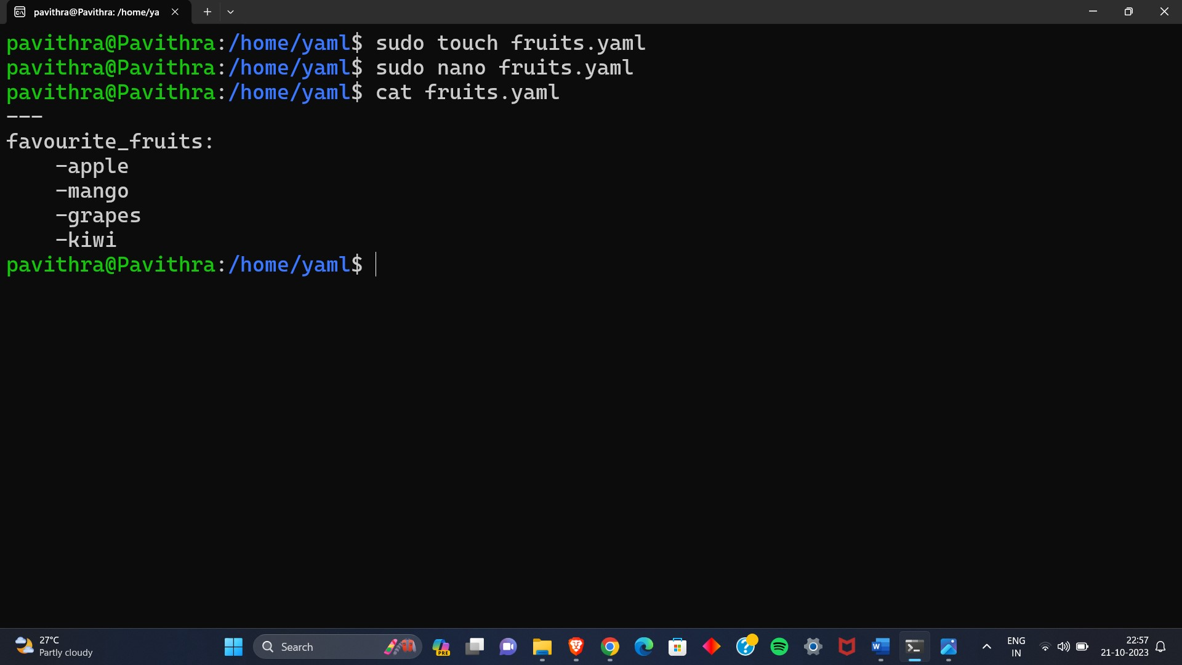

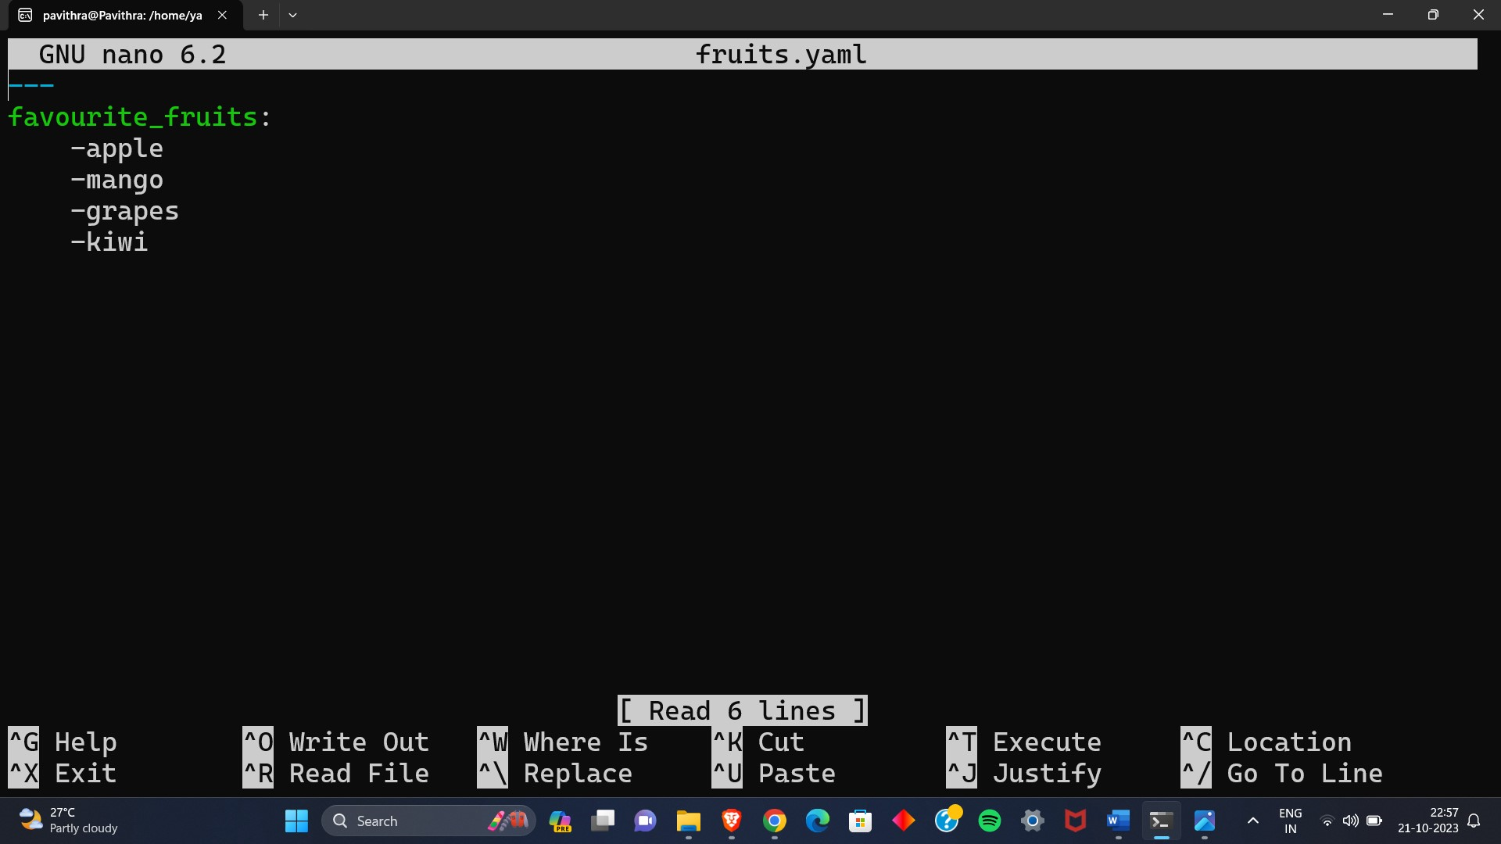

Lab 6: Nested Structures in YAML

Objective: Explore nested structures within YAML.

Task:

1. Create a YAML file named “data.yaml”

2. Define a nested structure representing a fictitious organization with

departments and employees.

3. Use YAML syntax to add, update, or remove data within the nested

structure.

4. Save and validate the YAML file.

Solution:

Steps to be Followed:

Step 1: Create a YAML file named "data.yaml".

Step 2: Open the "data.yaml" file in a text editor and add the following content.

Step 3: Use YAML syntax to add, update, or remove data within the nested structure. For example, to add a new employee to the HR department.

Step 4: Save the file in your text editor and Validate that the YAML file is correctly formatted using a YAML validator.

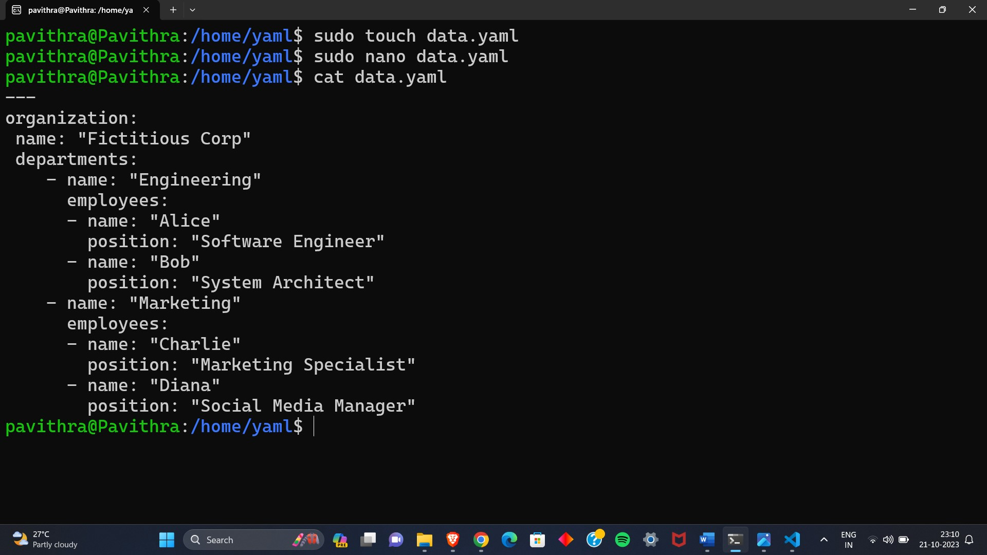

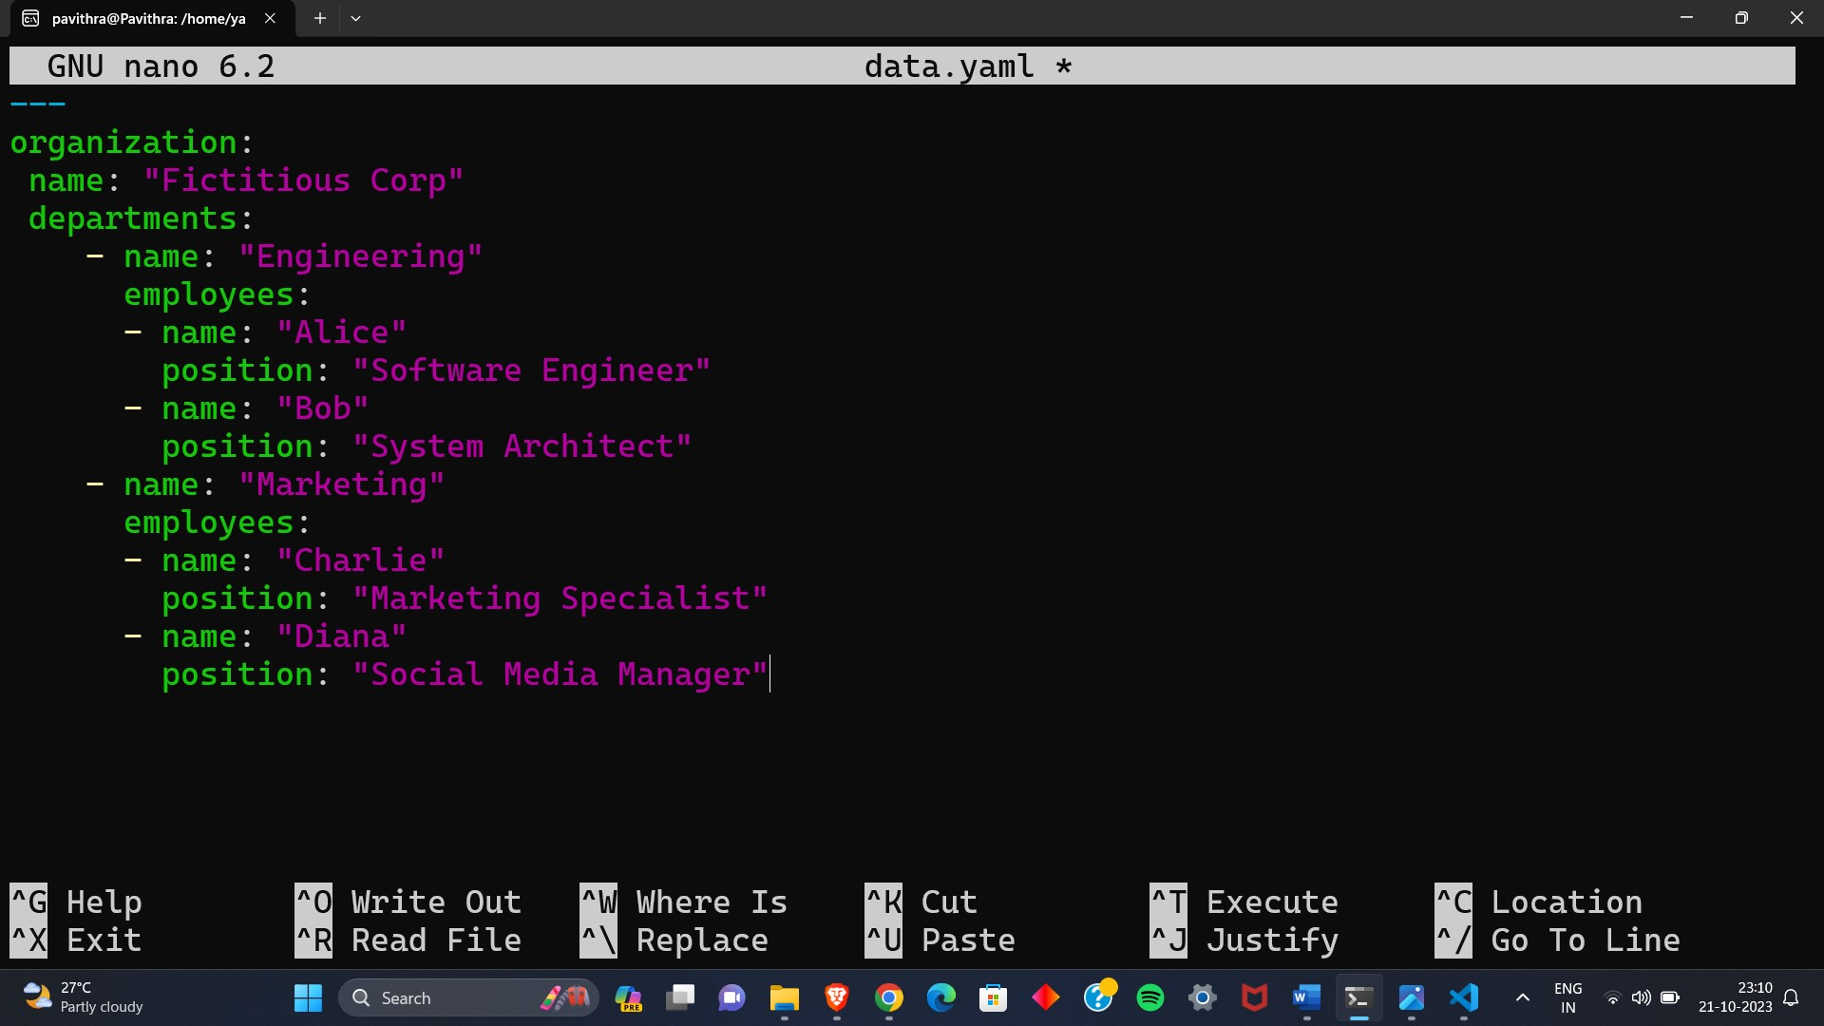

Lab 7: Create Classic Azure CI Pipeline for Angular Application

Objective: Set up a classic Azure CI pipeline to build a simple Angular

application with unit testing using Jasmine and Karma.

Tasks:

1. Create an Azure DevOps project.

2. Set up a classic CI pipeline to build an Angular application.

3. Configure the pipeline to use Jasmine and Karma for unit testing.

4. Run the pipeline and validate the test results.

Solution:

Screen Shots:

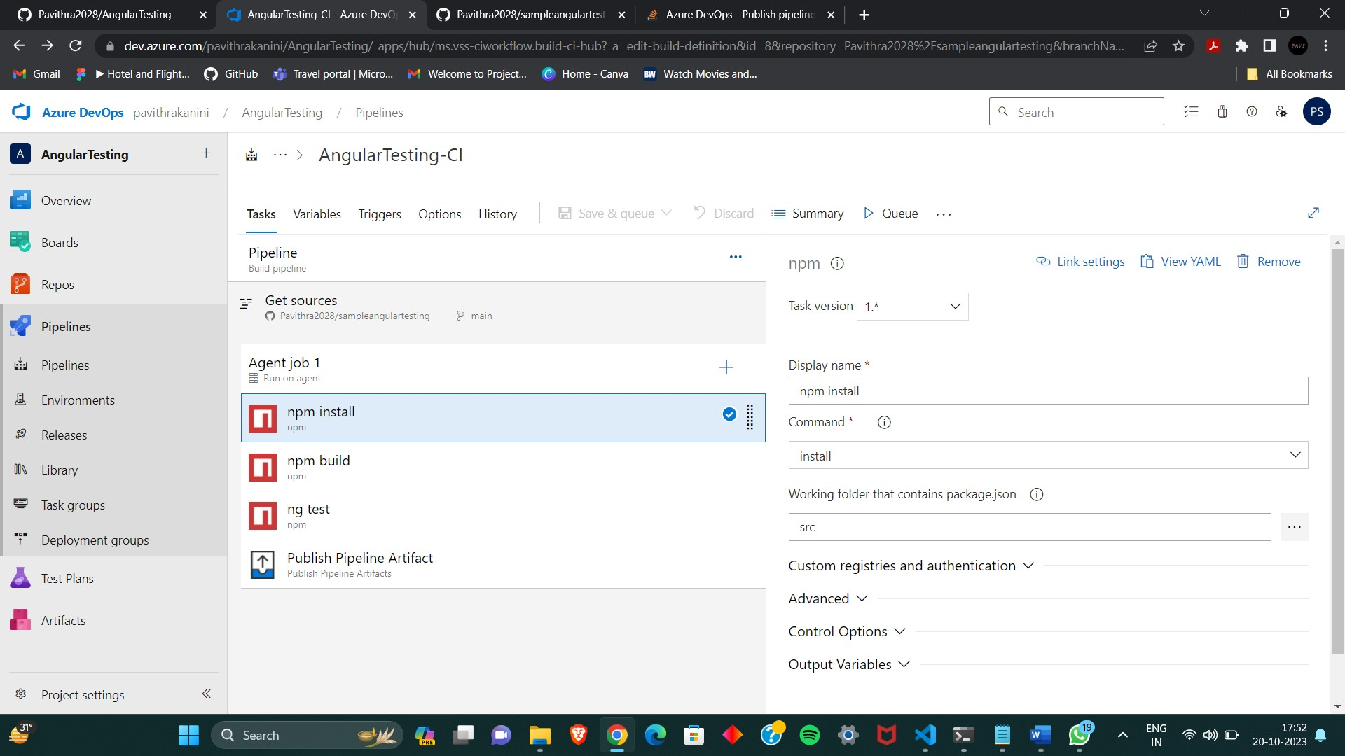

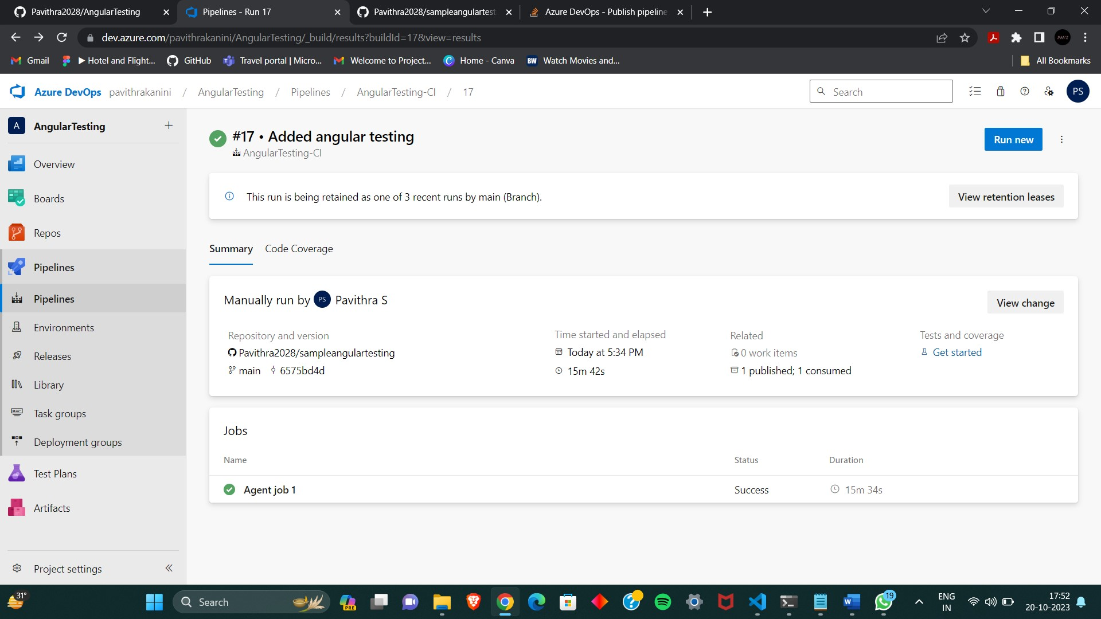

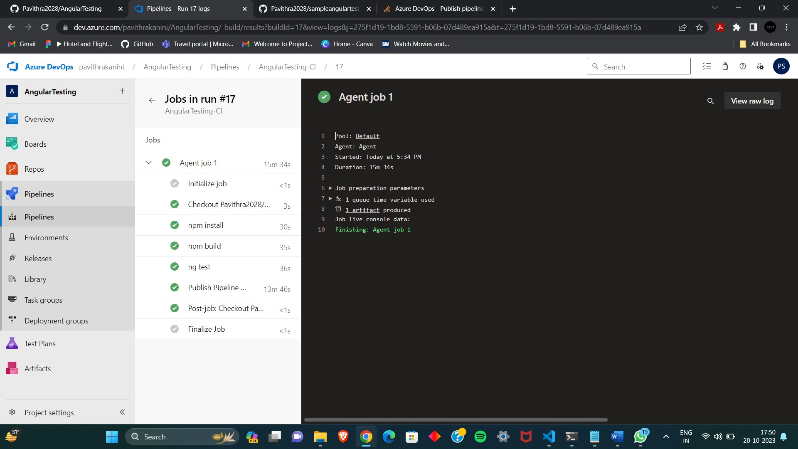

Lab 8: Create YAML Azure CI Pipeline for React Application

Objective: Create a YAML-based Azure CI pipeline to build a simple React

application with unit testing using Enzyme and Jest.

Tasks:

1. Create an Azure DevOps project.

2. Create a YAML-based CI pipeline to build a React application.

3. Configure the pipeline to use Enzyme and Jest for unit testing.

4. Trigger the pipeline and verify the test results.

Solution:

Screen Shots:

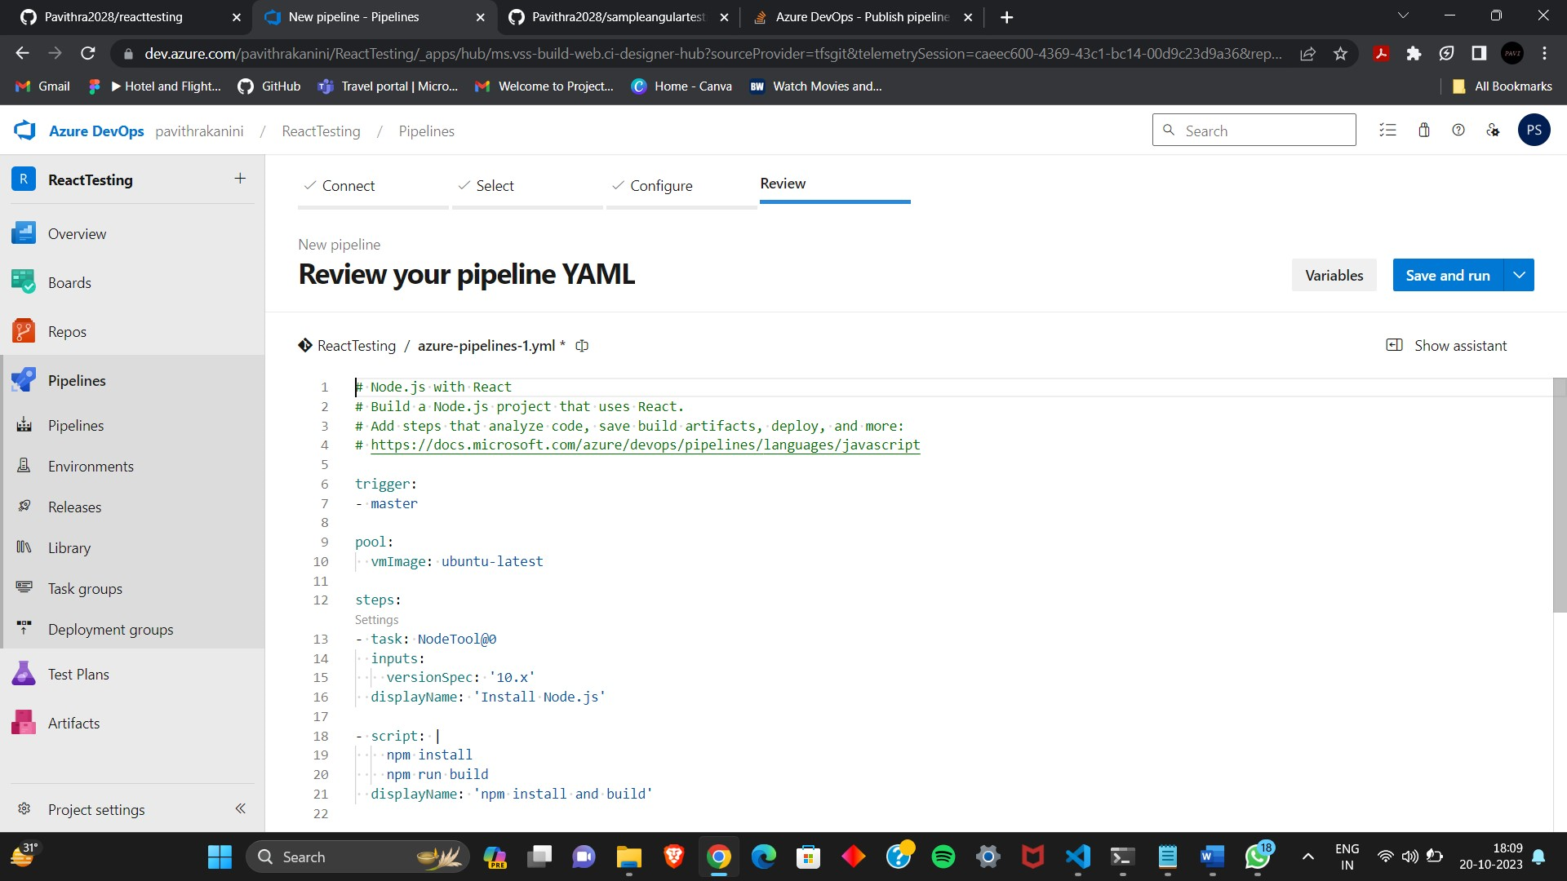

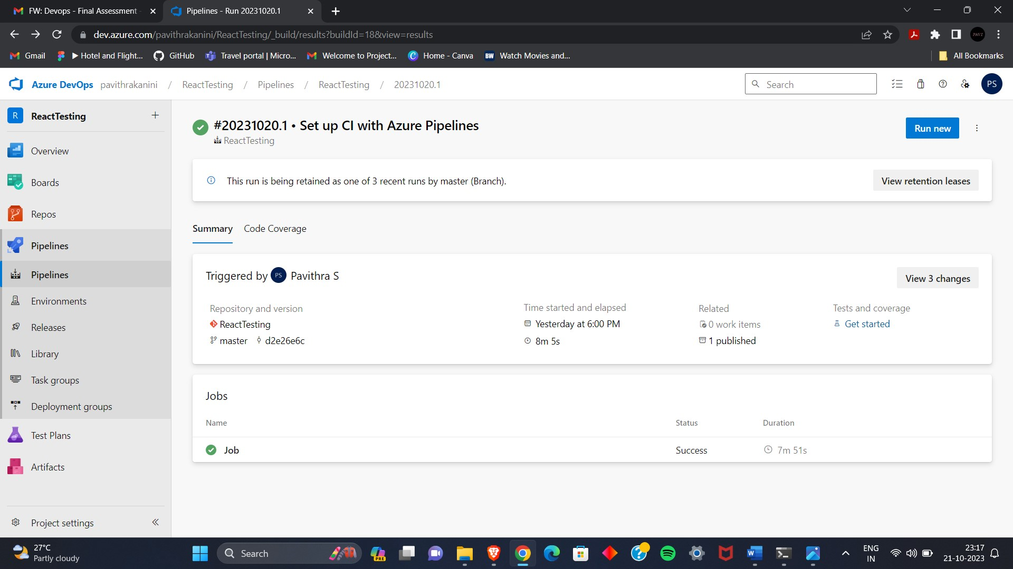

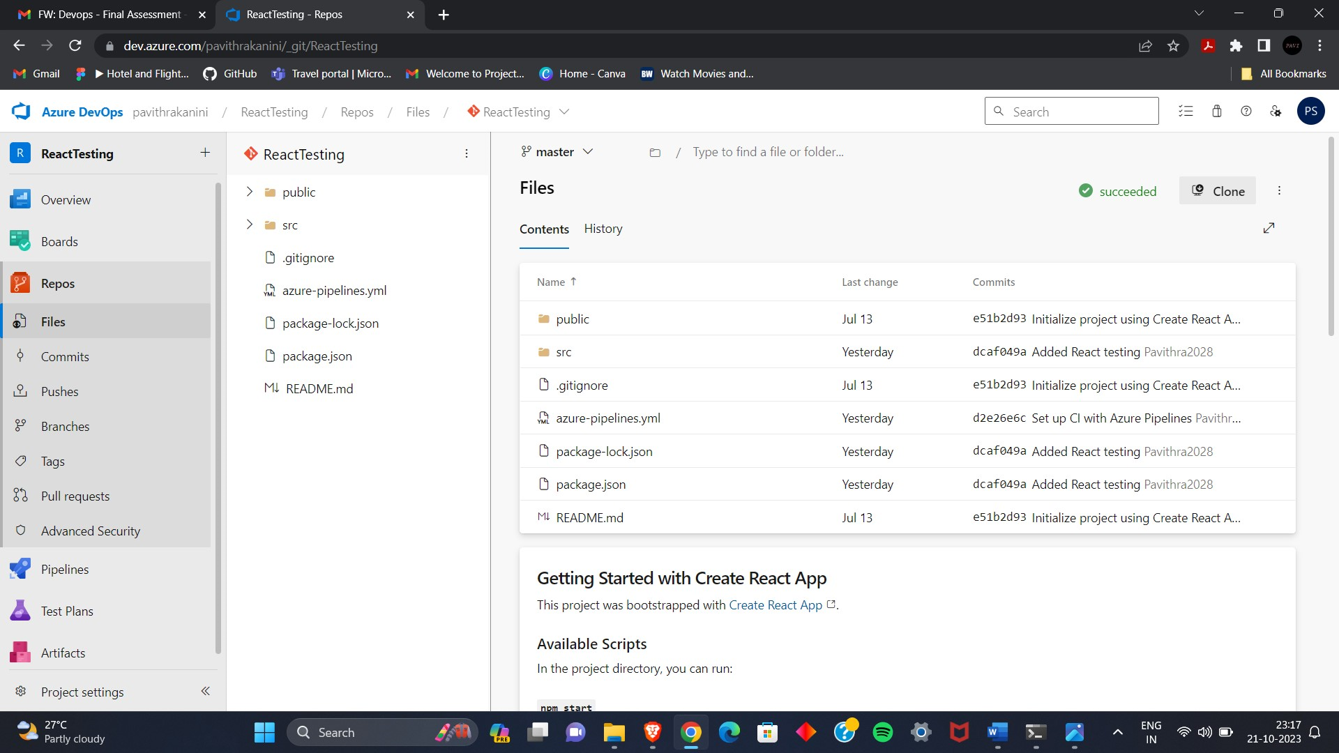

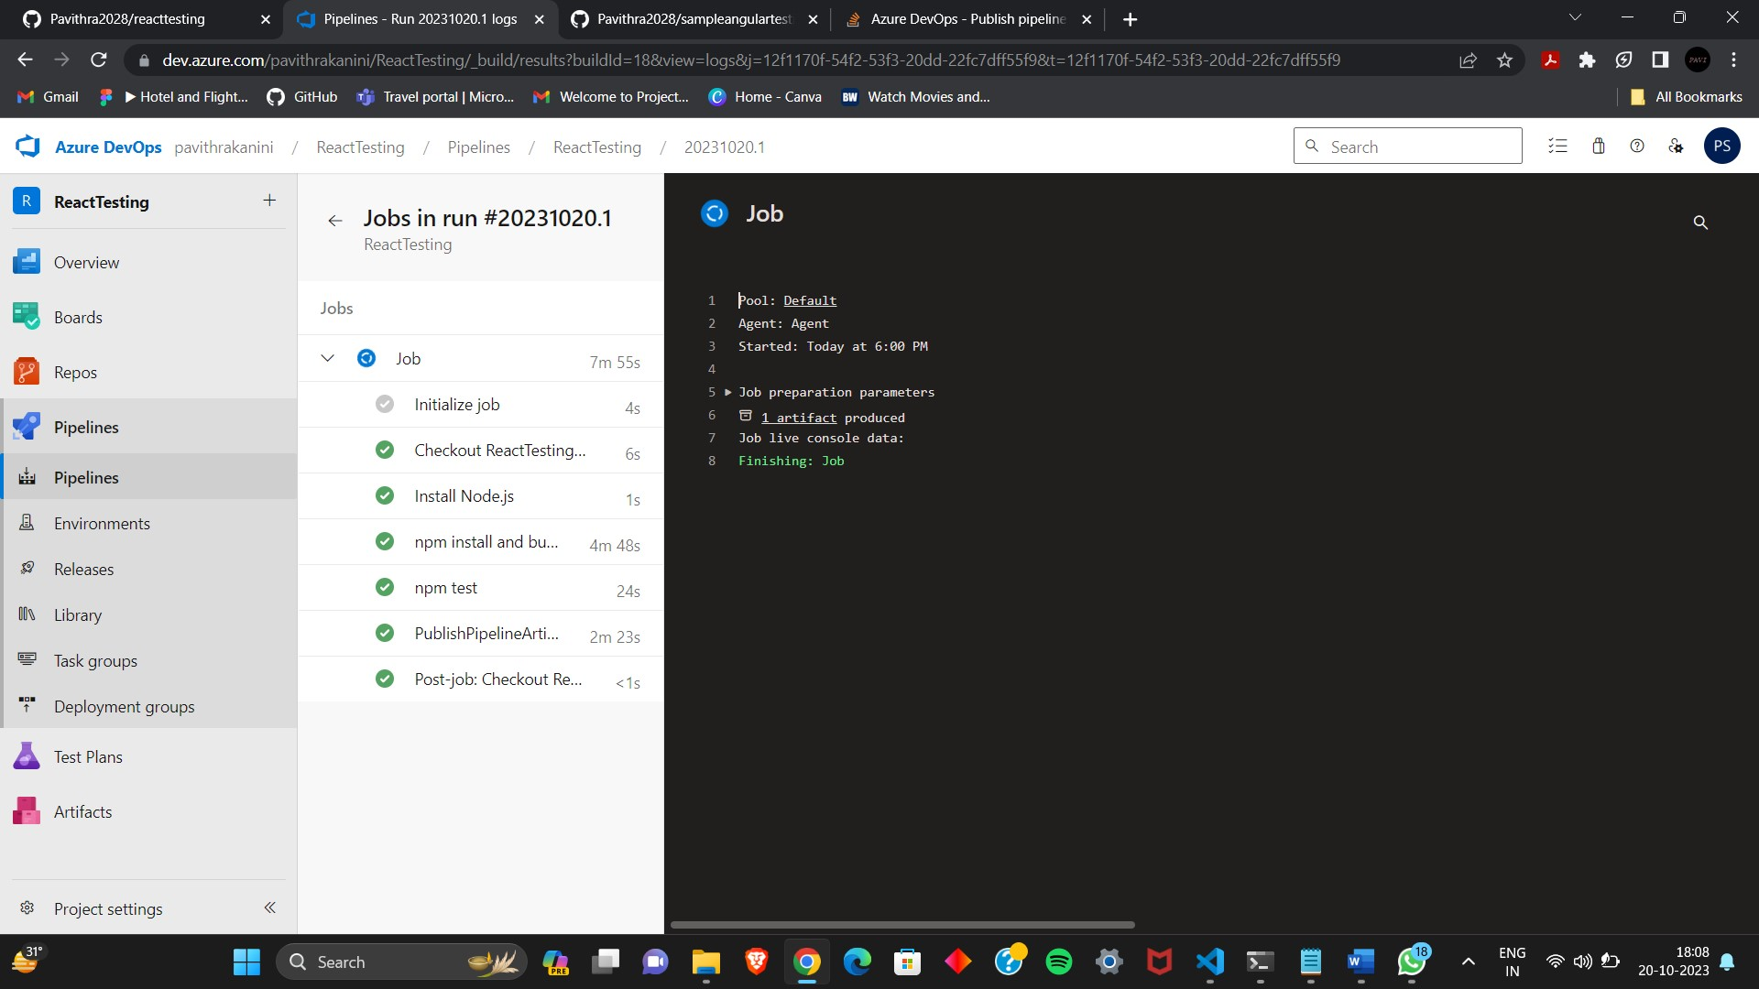

Lab 9: Create CI Pipeline for .NET Core Application with MS Unit Test

Objective: Create a CI pipeline, either classic or YAML, to build a .NET Core

application and run MS Unit tests.

Tasks:

1. Set up a new Azure DevOps project.

2. Create a CI/CD pipeline for a .NET Core application.

3. Configure the pipeline to use MS Unit tests.

4. Trigger the pipeline and validate the test results.

Solutions:

Screen Shots:

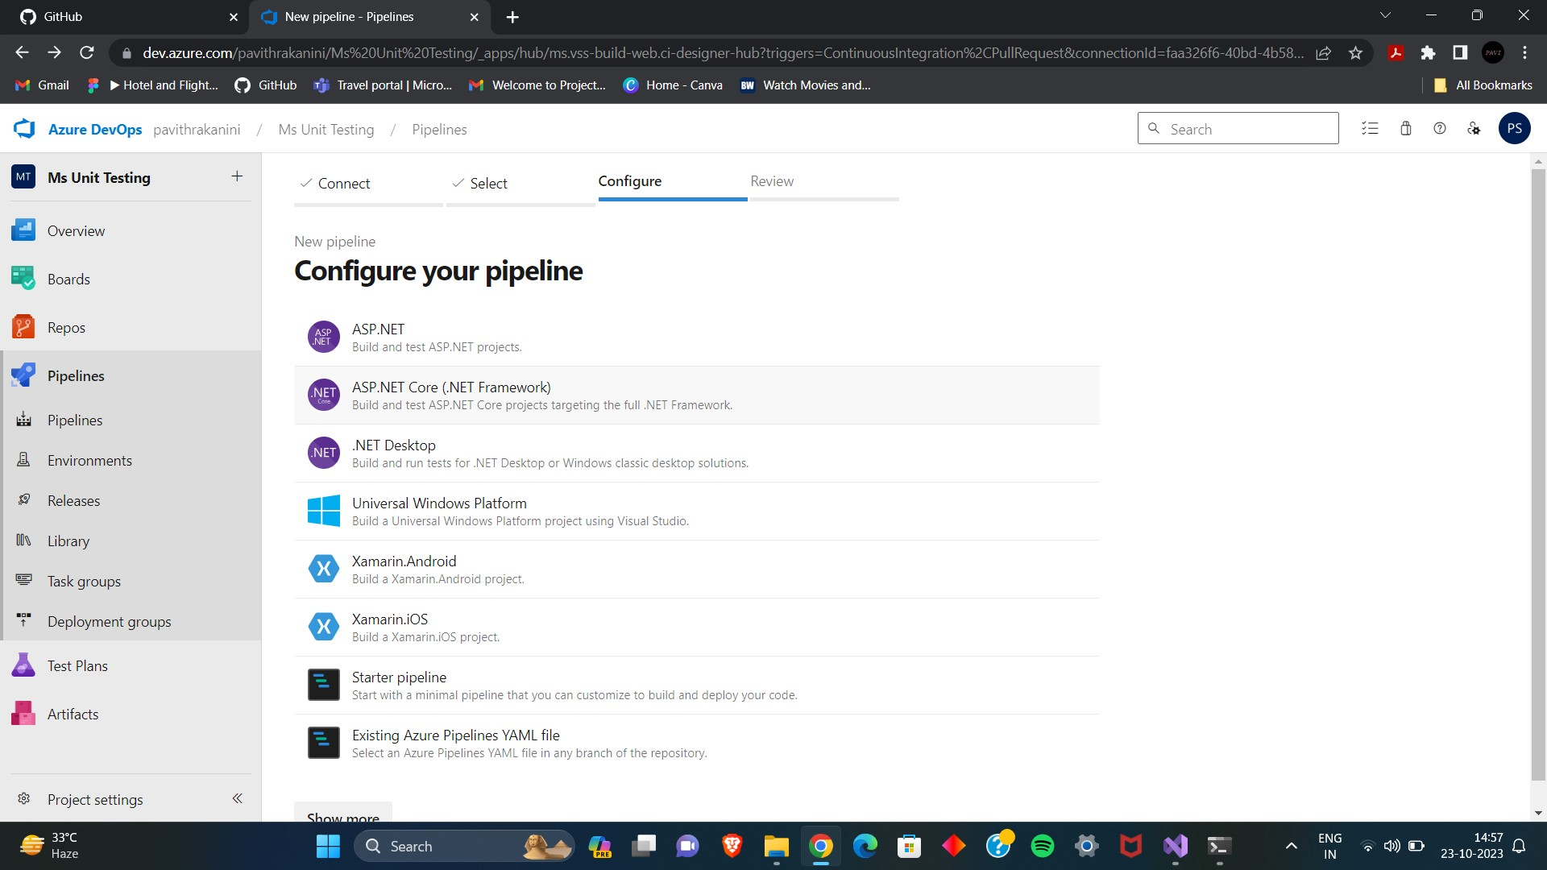

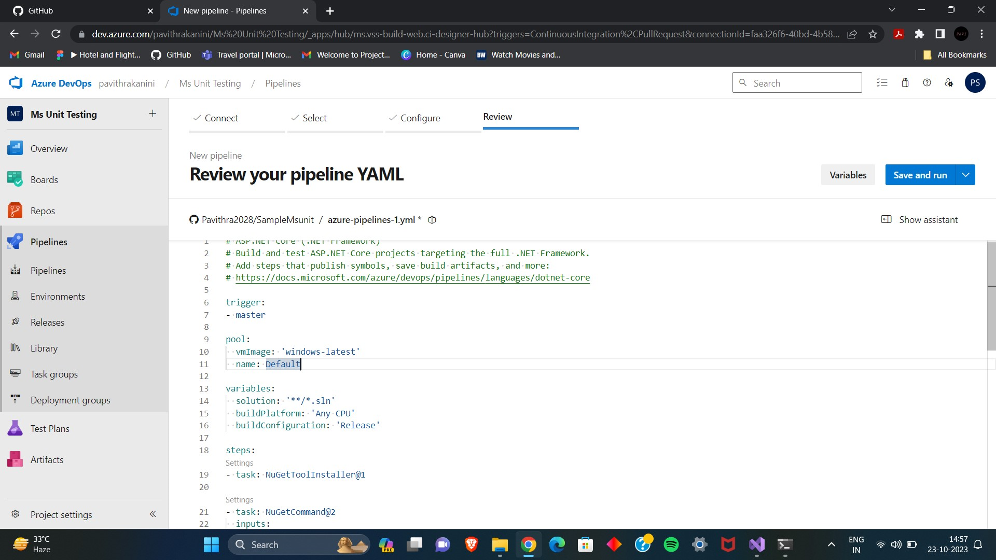

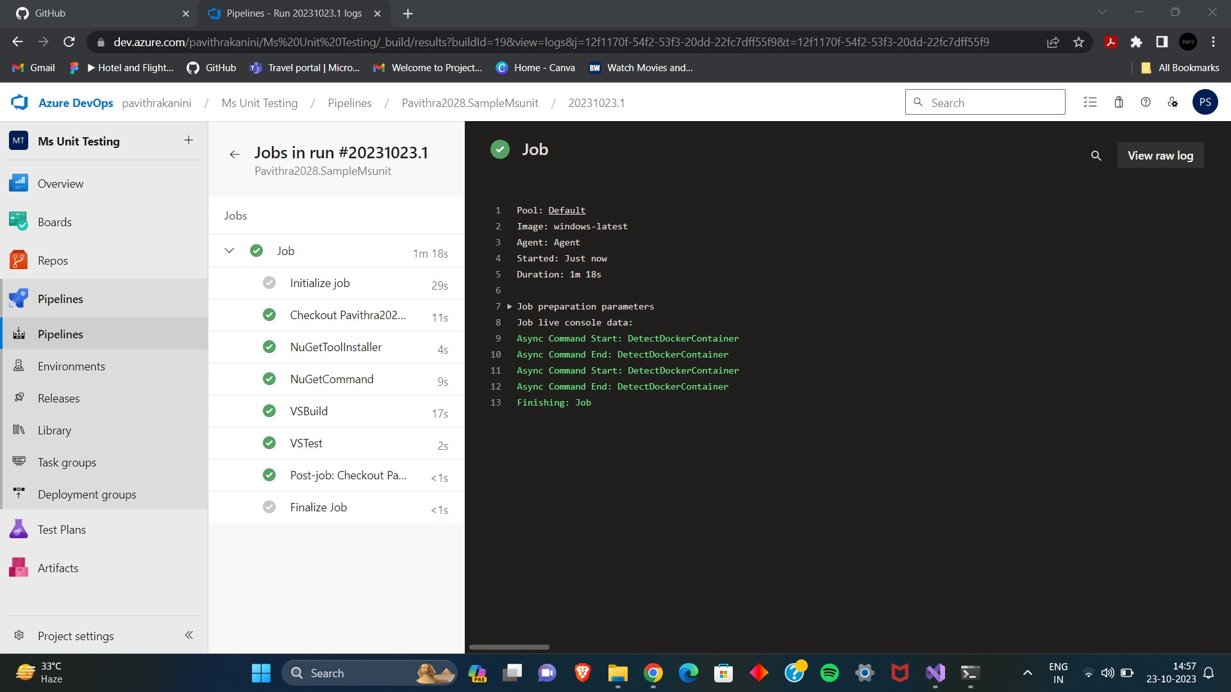

Lab 10: Creating a Docker Image for a .NET Core Web API and Running it in Rancher

Desktop

Objective: In this lab, you will create a Docker image for a sample .NET Core Web

API application and then run the Web API container in Rancher Desktop.

Prerequisites:

Rancher Desktop installed and running.

.NET Core SDK installed on your machine.

Tasks

Step 1: Create a .NET Core Web API Project

Step 2: Build the .NET Core Web API Project

Step 3: Dockerize the .NET Core Web API

Step 4: Build the Docker Image

Step 5: Run the Docker Container in Rancher Desktop

Step 6: Test the .NET Core Web API via swagger

Solution:

Screen Shots:

Step 1: Create a .NET Core Web API Project

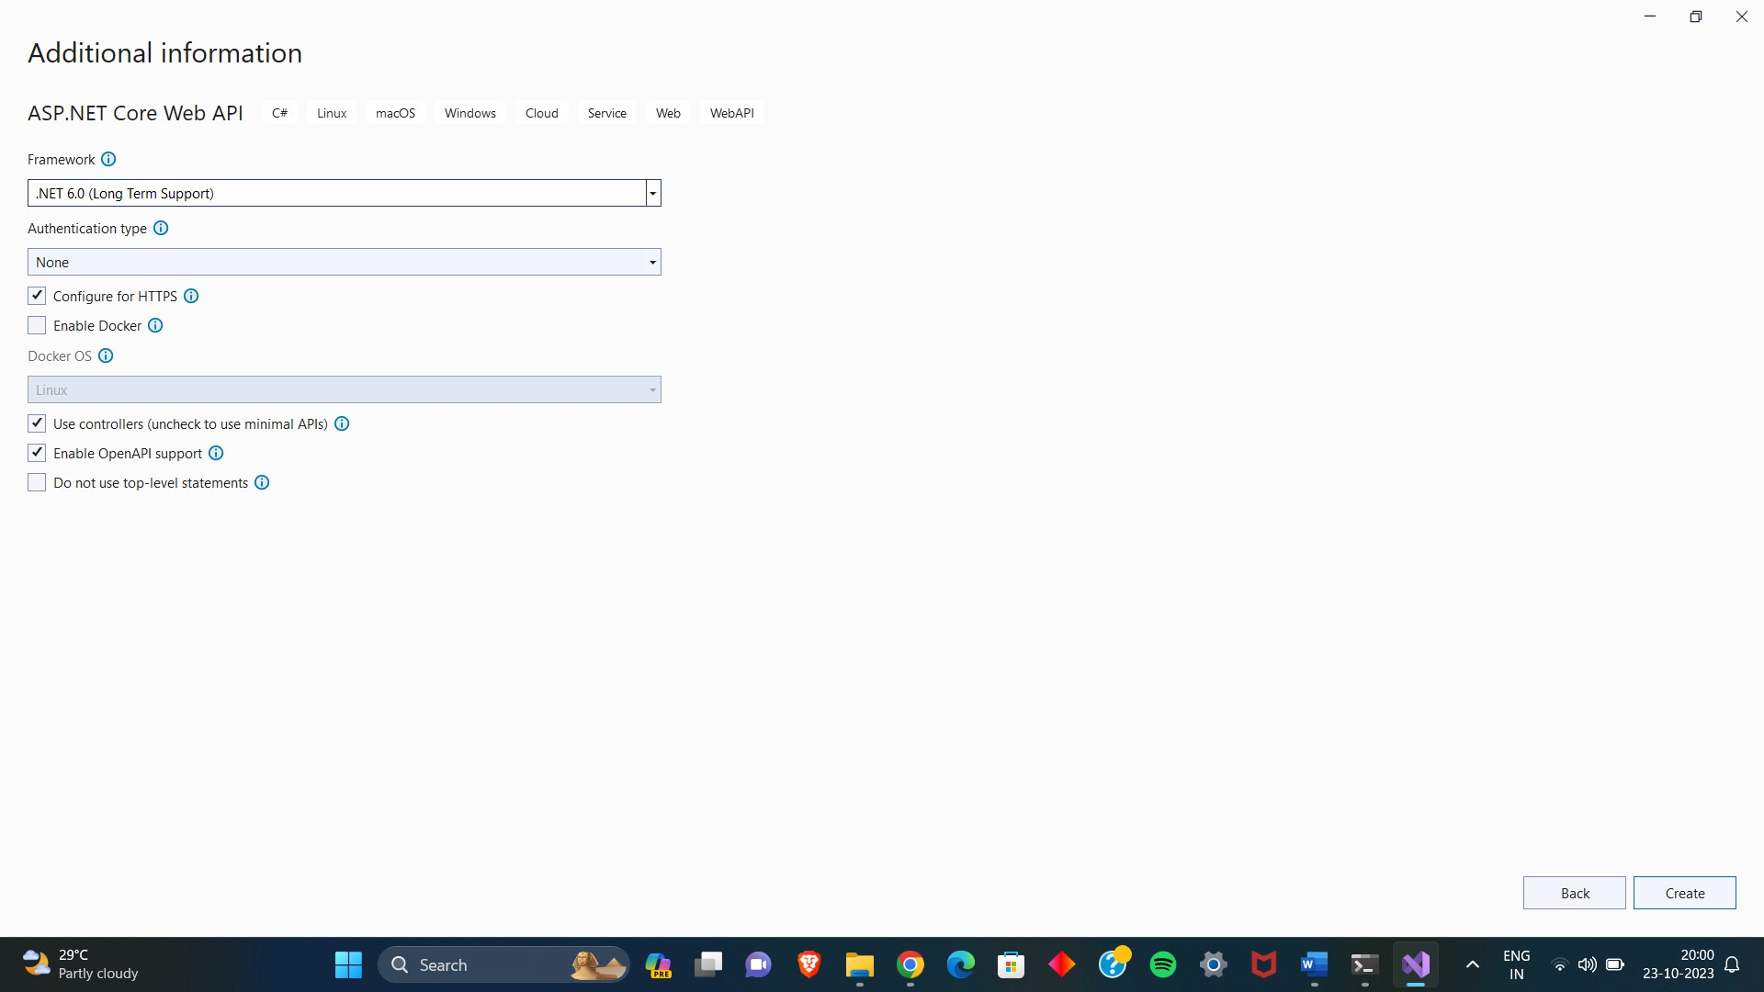

Step 2 & 3: Build the .NET Core Web API Project and Dockerize it

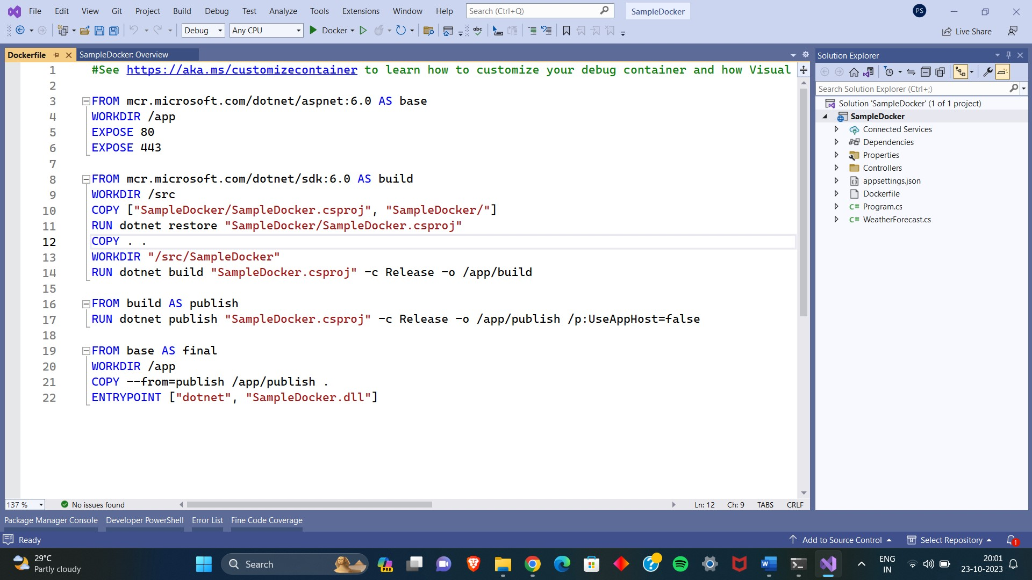

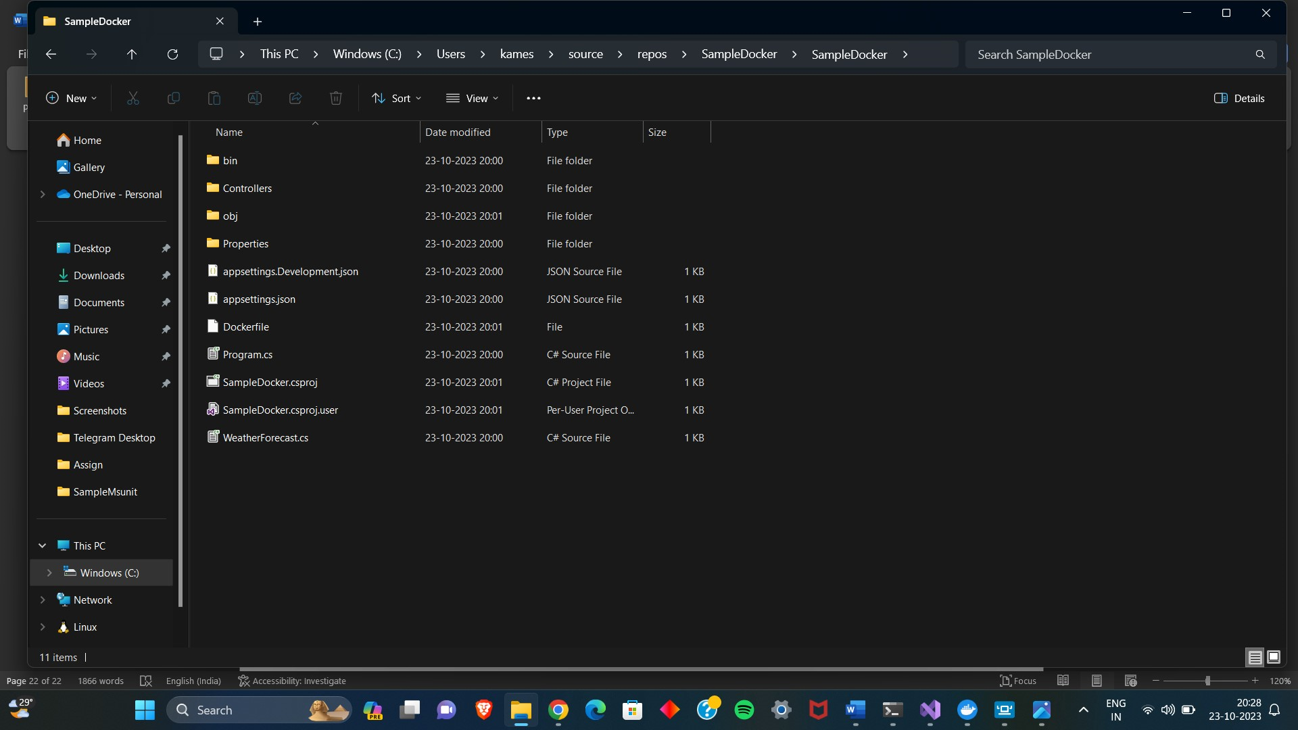

Step 4: Build the Docker Image

Listing all images :

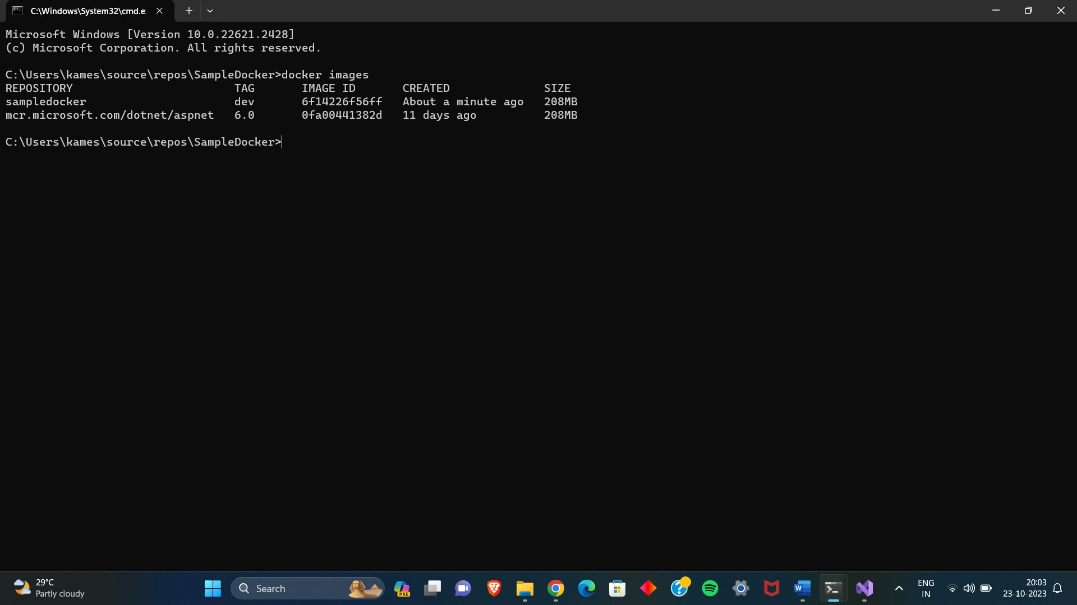

Building the docker file:

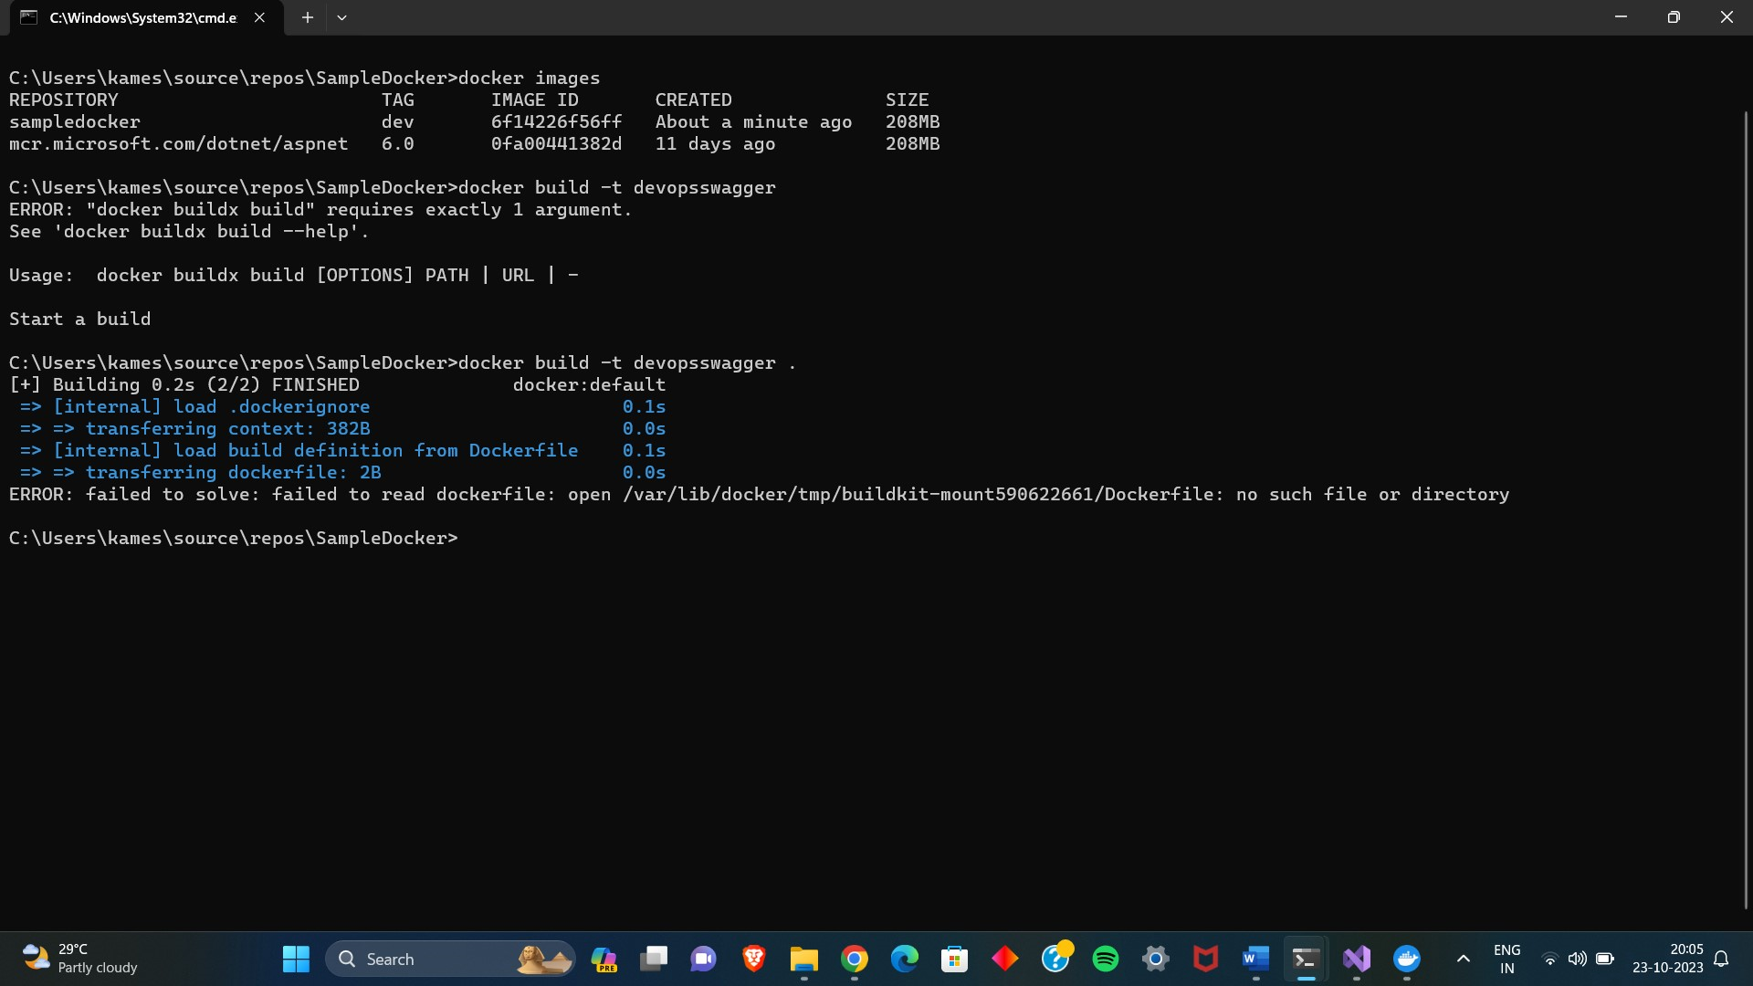

Step 6: Test the .NET Core Web API via swagger

Now I am running the docker image :

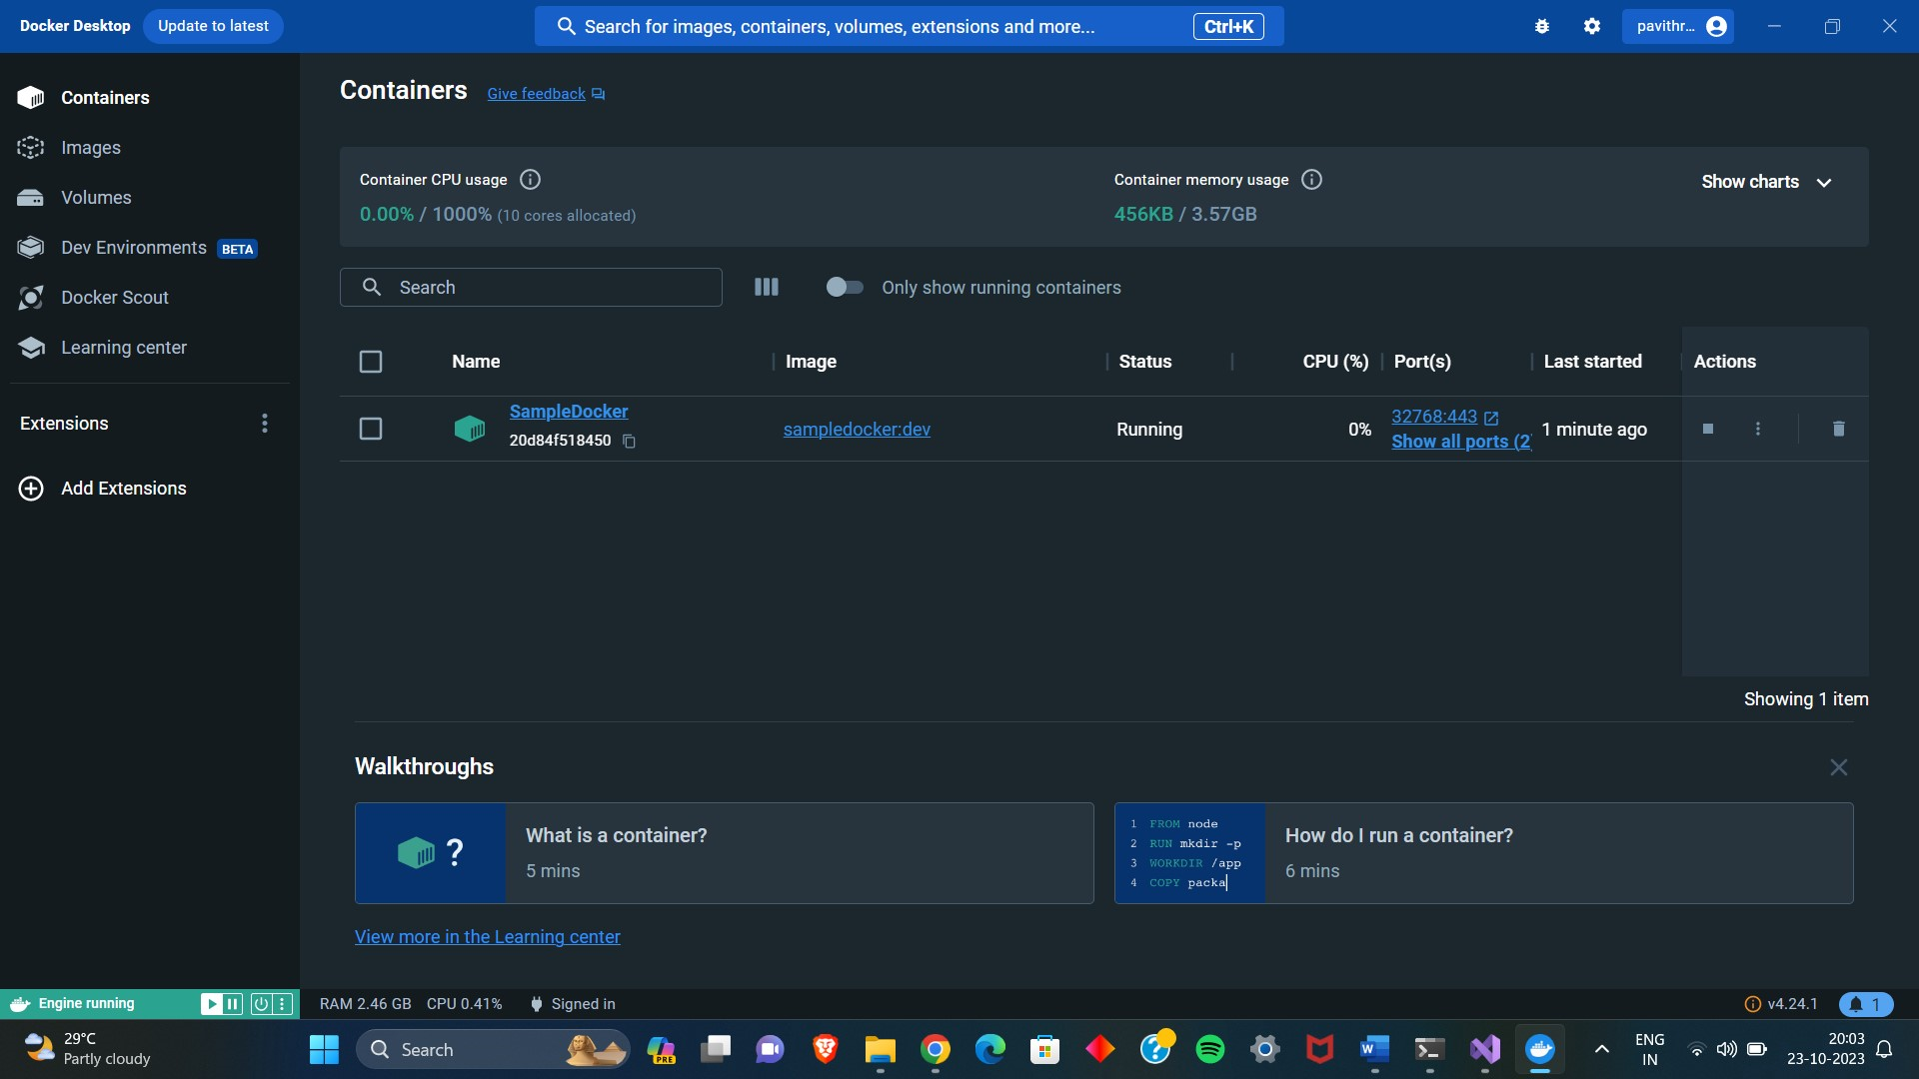

Finally the .net application runs on swagger via docker and rancher

